FIRST BAPTIST CHURCH CROSSNORE
April 12, 2026

Welcome and Announcements Jeremiah Parker

Worship Song “All Hail the Power of Jesus’ Name” Page 314

Worship Song “Amazing Grace, My Chains are Gone”

Worship with Tithes and Offerings (Prayer: Bobby Daniels)

Children’s Sermon Jeremiah Parker

Choral Music “In Christ Alone” Choir

Message Jeremiah Parker

Response “Jesus! What a Friend for Sinners” Page 156

Benediction

Nursery is provided for your children birth through 3 years of age. It is our hope that you will take advantage of this special service. If you are visiting with us and have need of the nursery, please ask for directions.
Serving God in the Nursery
This Morning: Rose Gates, Anna Hollifield,
Cora Lee Holifield, Caroline Hollifield
Sunday Night: Amanda Bentley and Kate Wiseman
Wednesday Night: Carolyn Parsons and Emma Wieman
Next Sunday: Marsha Hosey, Ashley Carpenter, Kay Grubb

*you can give online via our church website: firstbaptistcrossnore.com*

Deacon of the Week: Bobby Daniels

Next Week: Wayne Greene

Greeters/Welcome Center:
This Week: Glenn and Deliah Johnson

Next Week: Jeff and Valda Pollard

This Week……
Sunday 6:00pm—Evening Worship
Monday-Wednesday 7:00pm—Revival
Wednesday 8:00pm—Choir Practice


Prayer Corner: Sandy Mattox, Kermit Johnson, Pam Johnson,
Pastor Jeremiah Parker, Eddie Hudson, Haley Carroll, Lynn Woodie, Anna Ledford, Genesis McClain, Vickie Ollis, Kathy Vance Benfield, Ann Henson, Tracy Hoilman, Dennis Gragg, Regina Henson Hood, Garrett Henson, Shannon and Chesney Triplett, Lisa Keaton, Lisa Thomas, Chase Clark, Shannon Purdue, Kenny Wise, leaders, military, missionaries, the unsaved.
**If you have a name to add to the Prayer Corner, please call the church office (828-733-5243).

E Fall Gathering of the Avery Baptist Associaon will be held here at 6 PM on October 5
the
.
We will have the deacon ordinaon service for Je#ery Pollard and Mitchell McKinney at 11 AM
September 27
th
.
Harvest
The Fall Gathering of the Avery Bapst Associaon will be held here at 6 PM on October 5
th
.
We will have the deacon ordinaon service for Je#ery Pollard and Mitchell McKinney at 11 AM
September 27
th
.
Harvest



April 15, Gail Polson, Renne Vance; April 18, Sandy Mattox


 !"#$
%&%'(")$$$)*)(
+",$, ",-$ (
.!""" $-$
$$(/))",$$+-*
0""! ""(
.$$$"-$)(*
$!$ )(
+""*-1%112324556,(
!)$$",$)$)
7!(*" (*89:8'8+%:%8:%3%5

 !"#$
%&%'(")$$$)*)(
+",$, ",-$ (
.!""" $-$
$$(/))",$$+-*
0""! ""(
.$$$"-$)(*
$!$ )(
+""*-1%112324556,(
!)$$",$)$)
7!(*" (*89:8'8+%:%8:%3%5
6 VACATION BIBLE SCHOOL
Monday, July 13
th
- Friday, July 17
th
6-8pm
MARK YOUR CALENDER
Welcome First Time Visitors! Please pick up your gift and packet from the greeters in the vestibule.

Annie Armstrong Easter Offering
Final Collection: $6,956
Thank you for your faithful giving to missions!

Youth Summer Camp…BeDoTell
at Fort Caswell…June 22-26
Non refundable deposits of $100 are due as soon as possible. Please see Anna or Charity.
Please be in prayer for our youth and leaders as they prepare to attend camp this summer.
We will have a Baby Shower for Felece and Daniel Clark on Sunday, April 19th, following the evening service. It will be a diapers, wipes, and gift card shower. Ladies, please bring finger foods.


April is Food Roundup Month for NC Baptist Children’s Homes. We are collecting gift cards throughout this month to support them. You can place your gift card in the offering plate or bring by the church office.

Prayer Chain change….you will now receive prayer chain calls from a local number, 828-733-3859. Please add this number to your contacts list to ensure you receive the calls. After doing so, if you are still not receiving calls, please let the church office know.


2026 VACATION BIBLE SCHOOL
Monday, July 13th- Friday, July 17th 6pm-8pm

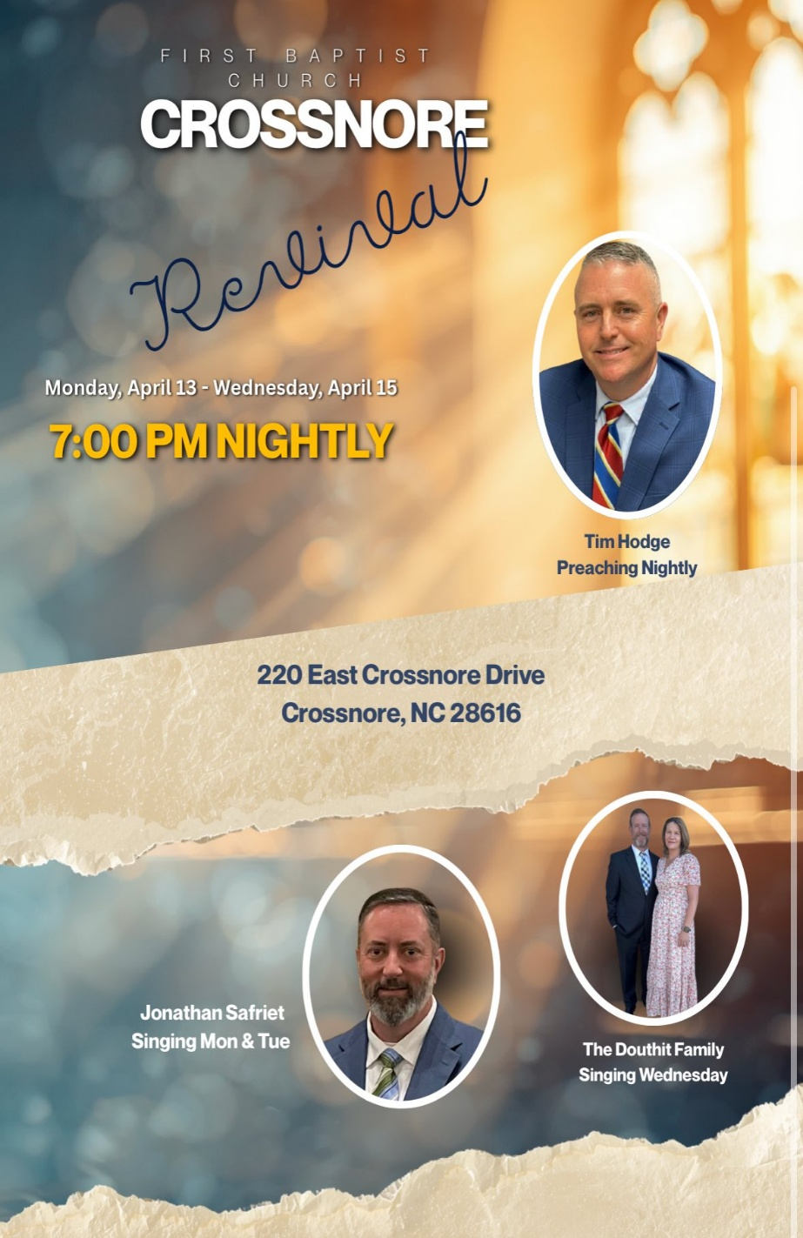

FIRST BAPTIST CHURCH CROSSNORE
PO Box 370
Crossnore, NC 28616
Church Office: 828-733-5243

Website: firstbaptistcrossnore.com

Office Hours: Monday-Friday 8:00am-3:00pm

Senior Pastor:
Pastor Jeremiah Parker (Cell: 828-291-8279)

Administrative Assistant: Renee Gouge

Music Director: Tara Andrews

Pianist: Stephanie Watson

Chairman of Deacons:
Mr. Randall Aldridge (828-260-5820)

Prayer Chain Numbers:
Kathy Aldridge 828-733-9613 or 828-260-3199
Kay Grubb 828-733-6431 or 828-387-6994

Our Mission Statement at First Baptist Church, Crossnore is:
“To glorify God together in ministry by prayerfully living by His Word and sharing the Gospel of Jesus Christ through missions."