FIRST BAPTIST CHURCH CROSSNORE
May 17, 2026

Welcome and Announcements Jeremiah Parker

Worship Song “Tell Me the Story of Jesus” Page 220

Worship Song “Mighty to Save”

Worship with Tithes and Offerings (Prayer: Mitchell McKinney)

Children’s Sermon Jeremiah Parker

Choral Music “Faithful God” Choir

Message Jeremiah Parker

Response “He Knows My Name” Page 44

Benediction

Nursery is provided for your children birth through 3 years of age. It is our hope that you will take advantage of this special service. If you are visiting with us and have need of the nursery, please ask for directions.
Serving God in the Nursery
This Morning: Marsha Hosey, Ashley Carpenter, Kay Grubb
Sunday Night: Rose Gates and Emma Wiseman
Wednesday Night: Carolyn Parsons and Emma Wiseman
Next Sunday: Alice McKinney, Frances Henline, Peggy Howell

Sunday School Attendance Last Sunday: 119
*you can give online via our church website: firstbaptistcrossnore.com*

Deacon of the Week: Mitchell McKinney

Next Week: Andy Rominger

Greeters/Welcome Center:

This Week: Pam Johnson

Next Week: Andy and Becky Rominger

This Week……
Sunday 6:00pm—Evening Worship
Wednesday 7:00pm—Bible Study
7:00pm—King’s Kids
7:00pm—Valley Students
8:00pm—Choir Practice


Prayer Corner: Rhonda Kassen, Mike Brandon, Sandy Mattox, Kermit Johnson, Pam Johnson, Pastor Jeremiah Parker, Eddie Hudson, Haley Carroll, Lynn Woodie, Anna Ledford, Genesis McClain, Vickie Ollis, Kathy Vance Benfield, Ann Henson, Tracy Hoilman, Dennis Gragg, Regina Henson Hood, Garrett Henson, Shannon and Chesney Triplett, Lisa Keaton, Lisa Thomas, Chase Clark, Shannon Purdue, Kenny Wise, leaders, military, missionaries, the unsaved.
**If you have a name to add to the Prayer Corner, please call the church office (828-733-5243).

E Fall Gathering of the Avery Baptist Associaon will be held here at 6 PM on October 5
the
.
We will have the deacon ordinaon service for Je#ery Pollard and Mitchell McKinney at 11 AM
September 27
th
.
Harvest
The Fall Gathering of the Avery Bapst Associaon will be held here at 6 PM on October 5
th
.
We will have the deacon ordinaon service for Je#ery Pollard and Mitchell McKinney at 11 AM
September 27
th
.
Harvest



May 20, Missy Isaacs, Riley Isaacs; May 24, Nathaniel Dixon


 !"#$
%&%'(")$$$)*)(
+",$, ",-$ (
.!""" $-$
$$(/))",$$+-*
0""! ""(
.$$$"-$)(*
$!$ )(
+""*-1%112324556,(
!)$$",$)$)
7!(*" (*89:8'8+%:%8:%3%5

 !"#$
%&%'(")$$$)*)(
+",$, ",-$ (
.!""" $-$
$$(/))",$$+-*
0""! ""(
.$$$"-$)(*
$!$ )(
+""*-1%112324556,(
!)$$",$)$)
7!(*" (*89:8'8+%:%8:%3%5
6 VACATION BIBLE SCHOOL
Monday, July 13
th
- Friday, July 17
th
6-8pm
MARK YOUR CALENDER

Welcome First Time Visitors! Please pick up your gift and packet from the greeters in the vestibule.

Youth Summer Camp…BeDoTell
at Fort Caswell…June 22-26
Non refundable deposits of $100 are due as soon as possible. Please see Anna or Charity.
Please be in prayer for our youth and leaders as they prepare to attend camp this summer.

Our Healing Hearts widow’s ministry will be meeting in the fellowship hall on Saturday, May 23rd, from 10am until 12 noon. Please see Eileen Garbett with questions.


It’s time for Avery Pregnancy Center’s baby bottle annual fundraiser. Please take an empty baby bottle from the basket at the front of the sanctuary and fill it with coins, paper currency, or checks and return it on Father’s Day, June 21st.

We will be taking the Birthday Offering next Sunday during the morning worship service.

2026 VACATION BIBLE SCHOOL
Monday, July 13th- Friday, July 17th 6-8pm

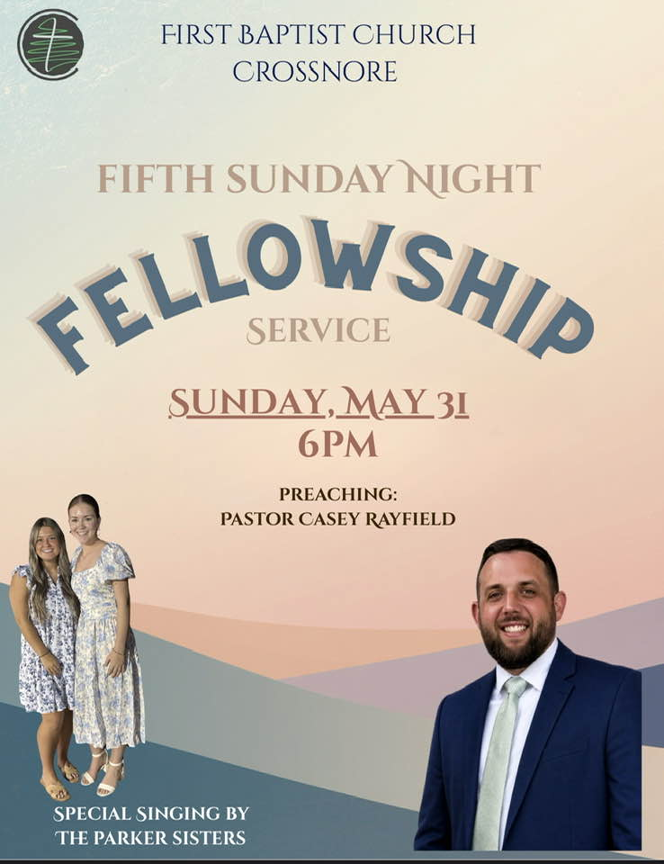

FIRST BAPTIST CHURCH CROSSNORE
PO Box 370
Crossnore, NC 28616
Church Office: 828-733-5243

Website: firstbaptistcrossnore.com

Office Hours: Monday-Friday 8:00am-3:00pm

Senior Pastor:
Pastor Jeremiah Parker (Cell: 828-291-8279)

Administrative Assistant: Renee Gouge

Music Director: Tara Andrews

Pianist: Stephanie Watson

Chairman of Deacons:
Mr. Randall Aldridge (828-260-5820)

Prayer Chain Numbers:
Kathy Aldridge 828-733-9613 or 828-260-3199
Kay Grubb 828-733-6431 or 828-387-6994

Our Mission Statement at First Baptist Church, Crossnore is:
“To glorify God together in ministry by prayerfully living by His Word and sharing the Gospel of Jesus Christ through missions."