FIRST BAPTIST CHURCH CROSSNORE
May 3, 2026

Welcome and Announcements Jeremiah Parker

Worship Song “Oh, How I Love Jesus” Page 560

Worship Song “What a Beautiful Name”

Worship with Tithes and Offerings (Prayer: Randall Aldridge)

Children’s Sermon Jeremiah Parker

Choral Music “In the Name of Jesus” Choir

Message Jeremiah Parker

Response “The Heart of Worship” Page 127

Benediction

Nursery is provided for your children birth through 3 years of age. It is our hope that you will take advantage of this special service. If you are visiting with us and have need of the nursery, please ask for directions.
Serving God in the Nursery
This Morning: Reed and Buffy Clark, Valda Pollard
Sunday Night: Paul and Emma Wiseman
Wednesday Night: Lorene Cuthbertson and Noelle Gates
Next Sunday: Rose Gates, Anna Hollifield,
Cora Lee Hollifield, Caroline Hollifield

Sunday School Attendance Last Sunday: 104
*you can give online via our church website: firstbaptistcrossnore.com*

Deacon of the Week: Randall Aldridge

Next Week: Bobby Watson

Greeters/Welcome Center:

This Week: Tim Farthing

Next Week: Kenny and Linda Poteat

This Week……
Sunday 6:00pm—Evening Worship
Wednesday 7:00pm—Family Missions Night
7:00pm—King’s Kids
7:00pm—Valley Students
8:00pm—Choir Practice


Prayer Corner: Mike Brandon, Sandy Mattox, Kermit Johnson, Pam Johnson, Pastor Jeremiah Parker, Eddie Hudson, Haley Carroll, Lynn Woodie, Anna Ledford, Genesis McClain, Vickie Ollis, Kathy Vance Benfield, Ann Henson, Tracy Hoilman, Dennis Gragg, Regina Henson Hood, Garrett Henson, Shannon and Chesney Triplett, Lisa Keaton, Lisa Thomas, Chase Clark, Shannon Purdue, Kenny Wise, leaders, military, missionaries, the unsaved.
**If you have a name to add to the Prayer Corner, please call the church office (828-733-5243).

E Fall Gathering of the Avery Baptist Associaon will be held here at 6 PM on October 5
the
.
We will have the deacon ordinaon service for Je#ery Pollard and Mitchell McKinney at 11 AM
September 27
th
.
Harvest
The Fall Gathering of the Avery Bapst Associaon will be held here at 6 PM on October 5
th
.
We will have the deacon ordinaon service for Je#ery Pollard and Mitchell McKinney at 11 AM
September 27
th
.
Harvest



May 5, Carrie Pritchard; May 7, Alyssa Parsons; May 8, Mary Aldridge, Mark Henline; May 10, Diana Watson


 !"#$
%&%'(")$$$)*)(
+",$, ",-$ (
.!""" $-$
$$(/))",$$+-*
0""! ""(
.$$$"-$)(*
$!$ )(
+""*-1%112324556,(
!)$$",$)$)
7!(*" (*89:8'8+%:%8:%3%5

 !"#$
%&%'(")$$$)*)(
+",$, ",-$ (
.!""" $-$
$$(/))",$$+-*
0""! ""(
.$$$"-$)(*
$!$ )(
+""*-1%112324556,(
!)$$",$)$)
7!(*" (*89:8'8+%:%8:%3%5
6 VACATION BIBLE SCHOOL
Monday, July 13
th
- Friday, July 17
th
6-8pm
MARK YOUR CALENDER

Welcome First Time Visitors! Please pick up your gift and packet from the greeters in the vestibule.

Youth Summer Camp…BeDoTell
at Fort Caswell…June 22-26
Non refundable deposits of $100 are due as soon as possible. Please see Anna or Charity.
Please be in prayer for our youth and leaders as they prepare to attend camp this summer.
We will be taking a Love Offering this morning for Dalton Harmon to show our love and appreciation to him for serving in our youth department. After evening worship, join us in the fellowship hall for cake as we fellowship with him.

Our Healing Hearts widow’s ministry will be meeting in the fellowship hall on Saturday, May 23rd, from 10am until 12 noon. Please see Eileen Garbett with questions.

2026 VACATION BIBLE SCHOOL
Monday, July 13th- Friday, July 17th 6-8pm
WE NEED YOUR HELP IN THE FOLLOWING AREAS:
CRAFTS, GROUP GUIDES, FOOD PREP/CLEANUP, YOUTH CLASS, MUSIC
Please see Pastor Jeremiah, Sara Wise, Kay Grubb,
or Margaret Ollis for more information
or to volunteer in one of the above areas.

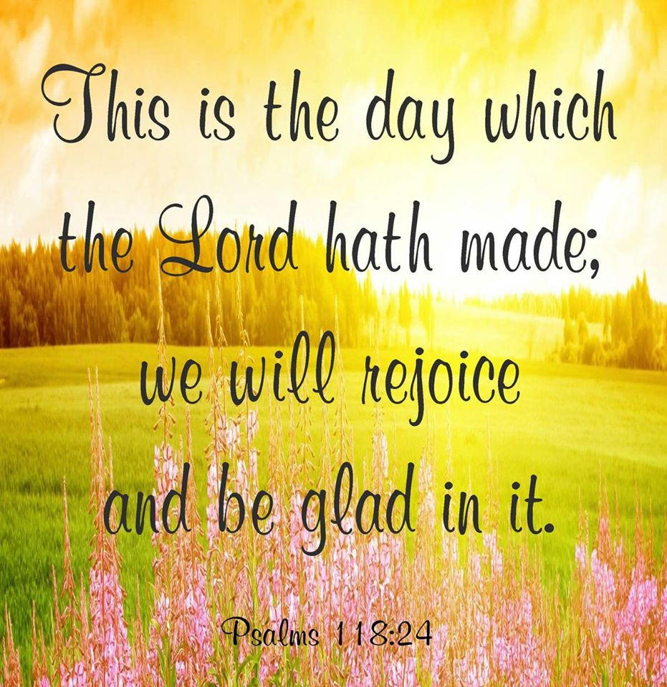

FIRST BAPTIST CHURCH CROSSNORE
PO Box 370
Crossnore, NC 28616
Church Office: 828-733-5243

Website: firstbaptistcrossnore.com

Office Hours: Monday-Friday 8:00am-3:00pm

Senior Pastor:
Pastor Jeremiah Parker (Cell: 828-291-8279)

Administrative Assistant: Renee Gouge

Music Director: Tara Andrews

Pianist: Stephanie Watson

Chairman of Deacons:
Mr. Randall Aldridge (828-260-5820)

Prayer Chain Numbers:
Kathy Aldridge 828-733-9613 or 828-260-3199
Kay Grubb 828-733-6431 or 828-387-6994

Our Mission Statement at First Baptist Church, Crossnore is:
“To glorify God together in ministry by prayerfully living by His Word and sharing the Gospel of Jesus Christ through missions."