FIRST BAPTIST CHURCH CROSSNORE
October 25, 2026

Welcome and Announcements Jeremiah Parker

Worship Song “Are You Washed in the Blood” Page 229

Worship Song “How Can It Be”

Worship with Tithes and Offerings (Prayer: Clay Cuthbertson)

Children’s Sermon Jeremiah Parker

Choral Music “Live for the Lord” Choir

Message Jeremiah Parker

Response “Come Ye Sinners” Page 420

Benediction

Nursery is provided for your children birth through 3 years of age. It is our hope that you will take advantage of this special service. If you are visiting with us and have need of the nursery, please ask for directions.
Serving God in the Nursery
This Morning: Alice McKinney and Frances Henline
Sunday Night: Eileen Garbett and Kathy Brown
Wednesday Night: Barbara Lindsey and Eileen Garbett
Next Sunday: Valda Pollard and Marsha Hosey

*you can give online via our church website: firstbaptistcrossnore.com*

Deacon of the Week: Clay Cuthbertson

Next Week: Andy Rominger

Greeters/Welcome Center:

This Week: Clay and Bev Cuthbertson

Next Week: Andy and Becky Rominger

This Week……
Sunday 6:00pm—Evening Worship service
Wednesday 7:00pm—Bible Study
7:00pm—King’s Kids
7:00pm—Valley Students
8:00pm—Choir Practice


Prayer Corner: Bill Watson, Alice Whittington, Sheila Kramer, Cecil Trivett, Stan McNabb, Rhonda Kassen, Sandy Mattox, Kermit Johnson, Pam Johnson, Pastor Jeremiah Parker, Eddie Hudson, Haley Carroll, Lynn Woodie, Anna Ledford, Genesis McClain, Vickie Ollis, Kathy Vance Benfield, Ann Henson, Tracy Hoilman, Dennis Gragg, Regina Henson Hood, Garrett Henson, Shannon and Chesney Triplett, Lisa Keaton, Lisa Thomas, Chase Clark, Shannon Purdue, Kenny Wise, leaders, military, missionaries, the unsaved.
**If you have a name to add to the Prayer Corner, please call the church office (828-733-5243).

E Fall Gathering of the Avery Baptist Associaon will be held here at 6 PM on October 5
the
.
We will have the deacon ordinaon service for Je#ery Pollard and Mitchell McKinney at 11 AM
September 27
th
.
Harvest
The Fall Gathering of the Avery Bapst Associaon will be held here at 6 PM on October 5
th
.
We will have the deacon ordinaon service for Je#ery Pollard and Mitchell McKinney at 11 AM
September 27
th
.
Harvest



October 29, Peggy Howell; Oct. 30, Marsha Hosey; Oct. 31, Diana Huskins


 !"#$
%&%'(")$$$)*)(
+",$, ",-$ (
.!""" $-$
$$(/))",$$+-*
0""! ""(
.$$$"-$)(*
$!$ )(
+""*-1%112324556,(
!)$$",$)$)
7!(*" (*89:8'8+%:%8:%3%5

 !"#$
%&%'(")$$$)*)(
+",$, ",-$ (
.!""" $-$
$$(/))",$$+-*
0""! ""(
.$$$"-$)(*
$!$ )(
+""*-1%112324556,(
!)$$",$)$)
7!(*" (*89:8'8+%:%8:%3%5
6 VACATION BIBLE SCHOOL
Monday, July 13
th
- Friday, July 17
th
6-8pm
MARK YOUR CALENDER

Welcome First Time Visitors! Please pick up your gift and packet from the greeters in the vestibule.
Please be working on your items for the
Christmas bazaar.
🎶 Join Us for the Christmas Cantata! 🎶
It’s that time of year again! Our choir is beginning preparations for the Christmas Cantata, Light of Christ, Born for Us, and we would love to welcome additional singers to join us for this special season. We’ll kick off our Christmas practices today, October 25th from 4:00–6:00 pm. If you’ve been thinking about joining the choir, now is the perfect time! Come be part of sharing the joy and beauty of the Christmas season through music. We’d love to have you!
October is Pastor Appreciation month. We will have cake and ice cream following the evening worship tonight, Sunday, October 25th, to celebrate our pastors and their wives. Please join us as we show Pastor Jeremiah and Mrs. Tori and Pastor Ean and Mrs. Angela our love and appreciation for all they do. There will be baskets for cards and gifts.
Thank you, church family, for all the prayers during Mike’s battle with cancer and his passing. Thank you for the trips to Boone, the visits, food, phone calls, and most of all the prayers for strength for me. Please keep me in your prayers in the continued days. God bless you all, Ann Henson
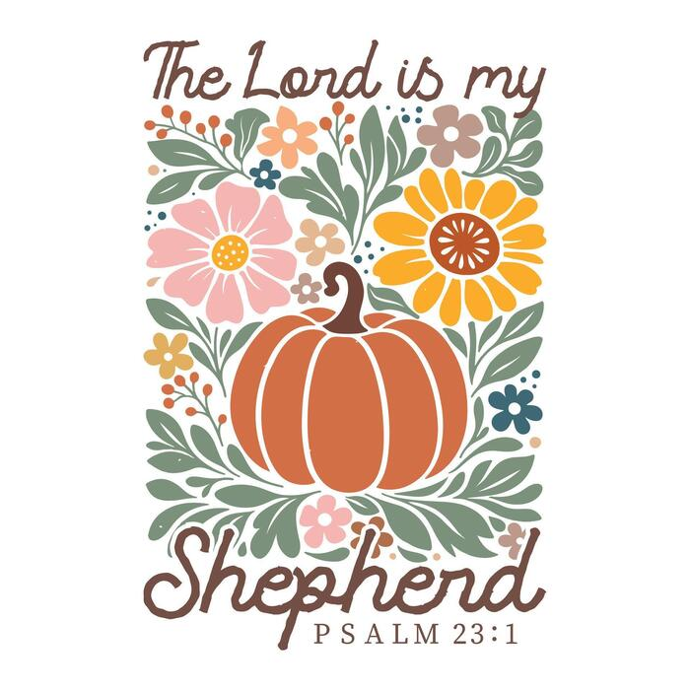

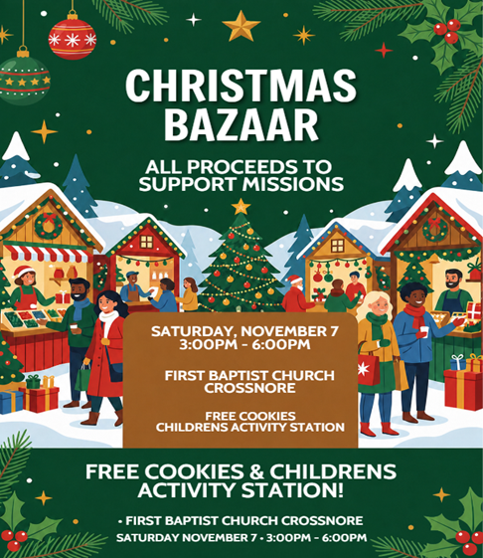

FIRST BAPTIST CHURCH CROSSNORE
PO Box 370
Crossnore, NC 28616
Church Office: 828-733-5243

Website: firstbaptistcrossnore.com

Office Hours: Monday-Friday 8:00am-3:00pm

Senior Pastor:
Pastor Jeremiah Parker (Cell: 828-291-8279)

Youth Pastor: Ean Martin

Administrative Assistant: Renee Gouge

Music Director: Tara Andrews

Pianist: Stephanie Watson

Chairman of Deacons:
Mr. Bobby Watson

Prayer Chain Numbers:
Kathy Aldridge 828-733-9613 or 828-260-3199
Kay Grubb 828-733-6431 or 828-387-6994

Our Mission Statement at First Baptist Church, Crossnore is:
“To glorify God together in ministry by prayerfully living by His Word and sharing the Gospel of Jesus Christ through missions."

