FIRST BAPTIST CHURCH CROSSNORE
July 5, 2026

Welcome and Announcements Jeremiah Parker

Worship Song “Soldiers of Christ, Arise” Page 658

Worship Song “When We Walk with The Lord” Page 500

Worship with Tithes and Offerings (Prayer: Bobby Watson)

Children’s Sermon Jeremiah Parker

Choral Music “I Will Heal Their Land” Choir

Message Jeremiah Parker

Response “My Faith Looks Up to Thee” Page509

Benediction

Nursery is provided for your children birth through 3 years of age. It is our hope that you will take advantage of this special service. If you are visiting with us and have need of the nursery, please ask for directions.
Serving God in the Nursery
This Morning: Reed and Buffy Clark, Valda Pollard
Sunday Night: Paul and Emma Wiseman
Wednesday Night: David and Sara Wise
Next Sunday: Rose Gates, Anna Hollifield,
Cora Lee Hollifield, Caroline Hollifield

*you can give online via our church website: firstbaptistcrossnore.com*

Deacon of the Week: Bobby Watson

Next Week: Andy Rominger

Greeters/Welcome Center:

This Week: Paul and Emma Wiseman

Next Week: Steve and Jean Branch

This Week……
Sunday 6:00pm—Evening Worship
Wednesday 7:00pm—Bible Study
7:00pm—King’s Kids
7:00pm—Valley Students
8:00pm—Choir Practice


Prayer Corner: Stan McNabb, Rhonda Kassen, Mike Brandon, Sandy Mattox, Kermit Johnson, Pam Johnson, Pastor Jeremiah Parker, Eddie Hudson, Haley Carroll, Lynn Woodie, Anna Ledford, Genesis McClain, Vickie Ollis, Kathy Vance Benfield, Ann Henson, Tracy Hoilman, Dennis Gragg, Regina Henson Hood, Garrett Henson, Shannon and Chesney Triplett, Lisa Keaton, Lisa Thomas, Chase Clark, Shannon Purdue, Kenny Wise, leaders, military, missionaries, the unsaved.
**If you have a name to add to the Prayer Corner, please call the church office (828-733-5243).

E Fall Gathering of the Avery Baptist Associaon will be held here at 6 PM on October 5
the
.
We will have the deacon ordinaon service for Je#ery Pollard and Mitchell McKinney at 11 AM
September 27
th
.
Harvest
The Fall Gathering of the Avery Bapst Associaon will be held here at 6 PM on October 5
th
.
We will have the deacon ordinaon service for Je#ery Pollard and Mitchell McKinney at 11 AM
September 27
th
.
Harvest



July 7, Steve Hicks, Harry Platt; July 10, Vann Johnson;
July 12, Tori Parker


 !"#$
%&%'(")$$$)*)(
+",$, ",-$ (
.!""" $-$
$$(/))",$$+-*
0""! ""(
.$$$"-$)(*
$!$ )(
+""*-1%112324556,(
!)$$",$)$)
7!(*" (*89:8'8+%:%8:%3%5

 !"#$
%&%'(")$$$)*)(
+",$, ",-$ (
.!""" $-$
$$(/))",$$+-*
0""! ""(
.$$$"-$)(*
$!$ )(
+""*-1%112324556,(
!)$$",$)$)
7!(*" (*89:8'8+%:%8:%3%5
6 VACATION BIBLE SCHOOL
Monday, July 13
th
- Friday, July 17
th
6-8pm
MARK YOUR CALENDER
Welcome First Time Visitors! Please pick up your gift and packet from the greeters in the vestibule.

The Nominating Committee is beginning work on the committees for 2026-2027 church year. Please pray and contact a member of the committee to see where you can serve.

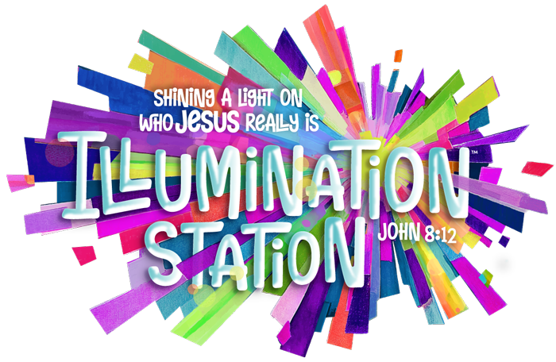
2026 VACATION BIBLE SCHOOL
Monday, July 13th- Friday, July 17th
6-8pm

We are so incredibly thankful for our church family and the love you've shown us after welcoming Charlie. Thank you to everyone who brought meals, checked in on us, and kept us in your prayers. Your kindness and generosity have been such a blessing during this special time as we adjust to life with our sweet little boy. We are truly grateful to be part of such a caring church family. Thank you for loving and supporting us so well. We appreciate each and every one of you more than words can express. ~Shane and Paige Poore

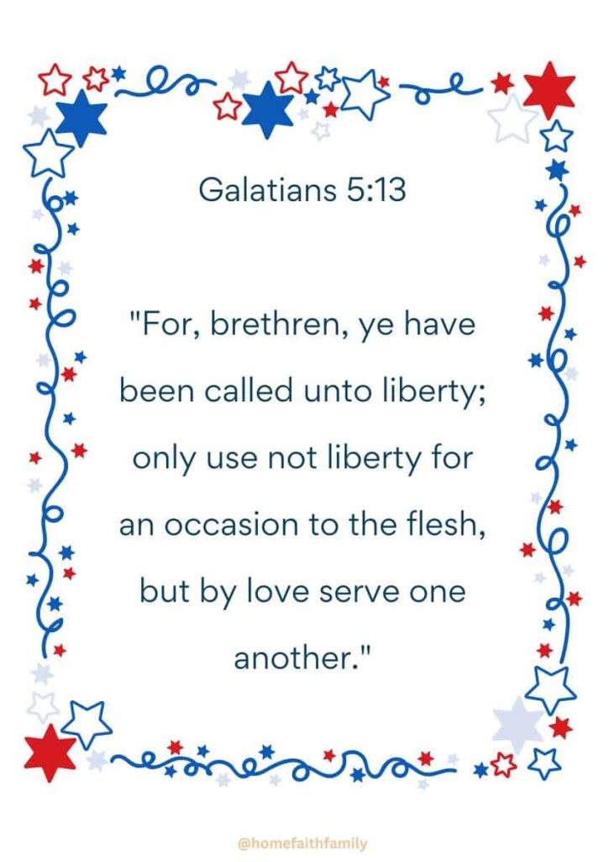

FIRST BAPTIST CHURCH CROSSNORE
PO Box 370
Crossnore, NC 28616
Church Office: 828-733-5243

Website: firstbaptistcrossnore.com

Office Hours: Monday-Friday 8:00am-3:00pm

Senior Pastor:
Pastor Jeremiah Parker (Cell: 828-291-8279)

Youth Pastor: Ean Martin

Administrative Assistant: Renee Gouge

Music Director: Tara Andrews

Pianist: Stephanie Watson

Chairman of Deacons:
Mr. Randall Aldridge (828-260-5820)

Prayer Chain Numbers:
Kathy Aldridge 828-733-9613 or 828-260-3199
Kay Grubb 828-733-6431 or 828-387-6994

Our Mission Statement at First Baptist Church, Crossnore is:
“To glorify God together in ministry by prayerfully living by His Word and sharing the Gospel of Jesus Christ through missions."

