FIRST BAPTIST CHURCH CROSSNORE
March 15, 2026

Welcome and Announcements Jeremiah Parker

Worship Song “The Old Rugged Cross” Page 230

Worship with Tithes and Offerings (Prayer: Mitchell McKinney)

Children’s Sermon Jeremiah Parker

Special Music Anaya Jackson and Josh Dellinger

Choral Music “Behold the Lamb” Choir

Message Will Gandy

Response “Victory in Jesus” Page 499

Benediction

Nursery is provided for your children birth through 3 years of age. It is our hope that you will take advantage of this special service. If you are visiting with us and have need of the nursery, please ask for directions.
Serving God in the Nursery
This Morning: Marsha Hosey, Ashley Carpenter, Kay Grubb
Sunday Night: no service
Wednesday Night: Carolyn Parsons and Emma Wiseman
Next Sunday: Alice McKinney, Frances Henline, Peggy Howell

Sunday School Attendance Last Week:107
*you can give online via our church website: firstbaptistcrossnore.com*

Deacon of the Week: Mitchell McKinney

Next Week: Bobby Watson

Greeters/Welcome Center:
This Week: Mitchell and Haley McKinney
Next Week: Bobby Watson

This Week……
Sunday 6:00pm—No Evening Service
Wednesday 7:00pm—Bible Study
7:00pm—King’s Kids
7:00pm—Valley Students
8:00pm—Choir Practice


Prayer Corner: Sandy Mattox, Kermit Johnson, Pam Johnson,
Pastor Jeremiah Parker, Eddie Hudson, Haley Carroll, Lynn Woodie, Anna Ledford, Genesis McClain, Vickie Ollis, Kathy Vance Benfield, Ann Henson, Tracy Hoilman, Dennis Gragg, Regina Henson Hood, Garrett Henson, Shannon and Chesney Triplett, Lisa Keaton, Lisa Thomas, Chase Clark, Shannon Purdue, Kenny Wise, leaders, military, missionaries, the unsaved.
**If you have a name to add to the Prayer Corner, please call the church office (828-733-5243).

E Fall Gathering of the Avery Baptist Associaon will be held here at 6 PM on October 5
the
.
We will have the deacon ordinaon service for Je#ery Pollard and Mitchell McKinney at 11 AM
September 27
th
.
Harvest
The Fall Gathering of the Avery Bapst Associaon will be held here at 6 PM on October 5
th
.
We will have the deacon ordinaon service for Je#ery Pollard and Mitchell McKinney at 11 AM
September 27
th
.
Harvest



March 17, Clyde McKinney, Zoe Parker; March 19, Kimber Haigler; March 20, Dee Clark; March 22, Mason Bentley, Axyl Payne

Welcome First Time Visitors! Please pick up your gift and packet from the greeters in the vestibule.


 !"#$
%&%'(")$$$)*)(
+",$, ",-$ (
.!""" $-$
$$(/))",$$+-*
0""! ""(
.$$$"-$)(*
$!$ )(
+""*-1%112324556,(
!)$$",$)$)
7!(*" (*89:8'8+%:%8:%3%5

 !"#$
%&%'(")$$$)*)(
+",$, ",-$ (
.!""" $-$
$$(/))",$$+-*
0""! ""(
.$$$"-$)(*
$!$ )(
+""*-1%112324556,(
!)$$",$)$)
7!(*" (*89:8'8+%:%8:%3%5
The Spring Camp Meeting at the
Tri-County Baptist Tabernacle will be March 16-20 and will feature Evangelist Dr. Mike Bagwell.

Please note that we will be having Communion today during our morning worship service.
026 VACATION BIBLE SCHOOL
Monday, July 13
th
- Friday, July 17
th
6-8pm
MARK YOUR CALENDER

We will be taking the Birthday Offering next Sunday.
We will celebrate Pastor Jeremiah’s birthday and Pastor Wife Appreciation for Mrs. Tori today with a dinner following the morning worship service. Everyone is welcome to join us! There will be no evening service.

2026 VACATION BIBLE SCHOOL
Monday, July 13th- Friday, July 17th 6pm-8pm

We will have a Baby Shower (gift cards) for
Olivia and Dustin Haigler next Sunday, March 22nd, following the evening worship service. Ladies, please bring finger foods.

The Baptist Women are doing a mission project to support Addy Singleton on her healing journey. “Addy Strong’
t-shirts are available for $33 and sweatshirts for $44. We will wear our shirts every 2nd Wednesday and have special prayer. Please see Alice McKinney or Frances Henline to order your shirt before Sunday, March 29th.

We will collect for the Annie Armstrong Easter Offering through Easter Sunday, April 5th, having the
Foot of the Cross Offering then. Each Sunday School Class
is encouraged to donate $100 for this offering.
Our Goal: $7,500 Collected to date: $200

Youth Summer Camp…BeDoTell
at Fort Caswell…June 22-26
Non refundable deposits of $100 are due as soon as possible. Please see Anna or Charity.
Please be in prayer for our youth and leaders as they prepare to attend camp this summer.

Ladies Retreat - Pigeon Forge
03-19-2026 (Thursday) / 03-21-2026 (Saturday)
Please pray for our ladies
as they travel and for their time of fellowship together.
Valley Students….D-Now is coming April 24-25
Cost is $50. Please sign up with any
Youth Committee member. Bring a friend!

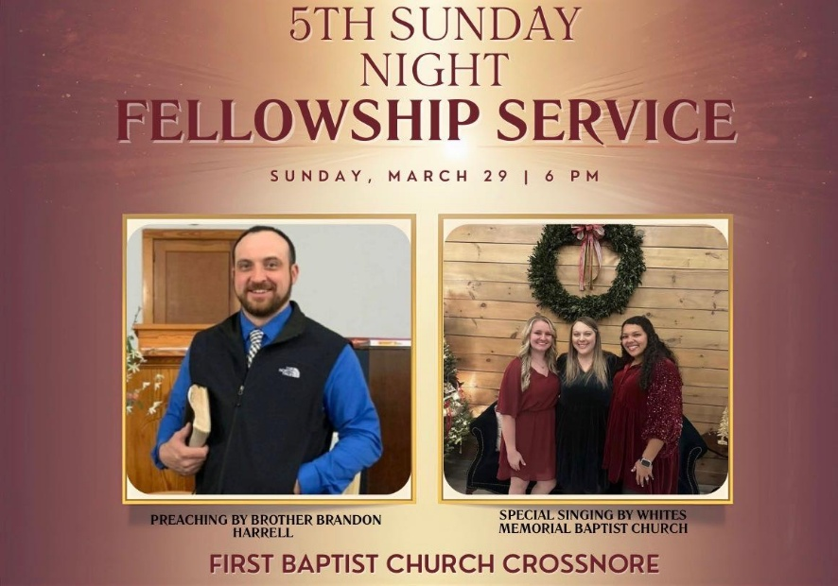

April 5, 2026
Sunrise Service 7am
At the cemetery located on Hwy 221
Worship Service 11am
No Sunday School Hour
No Evening Worship

FIRST BAPTIST CHURCH CROSSNORE
PO Box 370
Crossnore, NC 28616
Church Office: 828-733-5243

Website: firstbaptistcrossnore.com

Office Hours: Monday-Friday 8:00am-3:00pm

Senior Pastor:
Pastor Jeremiah Parker (Cell: 828-291-8279)

Administrative Assistant: Renee Gouge

Music Director: Tara Andrews

Pianist: Stephanie Watson

Chairman of Deacons:
Mr. Randall Aldridge (828-260-5820)

Prayer Chain Numbers:
Kathy Aldridge 828-733-9613 or 828-260-3199
Kay Grubb 828-733-6431 or 828-387-6994

Our Mission Statement at First Baptist Church, Crossnore is:
“To glorify God together in ministry by prayerfully living by His Word and sharing the Gospel of Jesus Christ through missions."