FIRST BAPTIST CHURCH CROSSNORE
September 13, 2026

Welcome and Announcements Jeremiah Parker

Worship Song “Praise to the Lord, the Almighty” Page 1

Worship Song “Indescribable” Page 50

Worship with Tithes and Offerings (Prayer: Wayne Greene)

Children’s Sermon Jeremiah Parker

Choral Music “I’ve Put My Hope in God” Choir

Message and Communion Jeremiah Parker

Response “He Knows My Name” Page 44

Benediction

Nursery is provided for your children birth through 3 years of age. It is our hope that you will take advantage of this special service. If you are visiting with us and have need of the nursery, please ask for directions.
Serving God in the Nursery
This Morning: Rose Gates, Anna Hollifield,
Cora Lee Hollifield, Caroline Hollifield
Sunday Night: Amanda Bentley and Kate Wiseman
Wednesday Night: Carolyn Parsons and Emma Wiseman
Next Sunday: Carolyn Parsons and Kay Grubb

Sunday School Attendance Last Sunday: 116
*you can give online via our church website: firstbaptistcrossnore.com*

Deacon of the Week: Wayne Greene

Next Week: Steve Hicks

Greeters/Welcome Center:

This Week: Wayne Greene

Next Week: Steve and Martha Hicks

This Week……
Sunday 6:00pm—Evening Worship
Wednesday 7:00pm—Bible Study
7:00pm—King’s Kids
7:00pm—Valley Students
8:00pm—Choir Practice


Prayer Corner: Cecil Trivett, Stan McNabb, Rhonda Kassen, Mike Brandon, Sandy Mattox, Kermit Johnson, Pam Johnson, Pastor Jeremiah Parker, Eddie Hudson, Haley Carroll, Lynn Woodie, Anna Ledford, Genesis McClain, Vickie Ollis, Kathy Vance Benfield, Ann Henson, Tracy Hoilman, Dennis Gragg, Regina Henson Hood, Garrett Henson, Shannon and Chesney Triplett, Lisa Keaton, Lisa Thomas, Chase Clark, Shannon Purdue, Kenny Wise, leaders, military, missionaries, the unsaved.
**If you have a name to add to the Prayer Corner, please call the church office (828-733-5243).

E Fall Gathering of the Avery Baptist Associaon will be held here at 6 PM on October 5
the
.
We will have the deacon ordinaon service for Je#ery Pollard and Mitchell McKinney at 11 AM
September 27
th
.
Harvest
The Fall Gathering of the Avery Bapst Associaon will be held here at 6 PM on October 5
th
.
We will have the deacon ordinaon service for Je#ery Pollard and Mitchell McKinney at 11 AM
September 27
th
.
Harvest



September 16, Renee Barrier; Sept. 18, Dale Aldridge, Ed Isaacs; Sept. 19, Randall Aldridge, Dennis Henson, Karen Carroll; Sept. 20, Jeffery Pollard; Sept. 21, Mitchell McKinney, Molly Gates


 !"#$
%&%'(")$$$)*)(
+",$, ",-$ (
.!""" $-$
$$(/))",$$+-*
0""! ""(
.$$$"-$)(*
$!$ )(
+""*-1%112324556,(
!)$$",$)$)
7!(*" (*89:8'8+%:%8:%3%5

 !"#$
%&%'(")$$$)*)(
+",$, ",-$ (
.!""" $-$
$$(/))",$$+-*
0""! ""(
.$$$"-$)(*
$!$ )(
+""*-1%112324556,(
!)$$",$)$)
7!(*" (*89:8'8+%:%8:%3%5
6 VACATION BIBLE SCHOOL
Monday, July 13
th
- Friday, July 17
th
6-8pm
MARK YOUR CALENDER
Welcome First Time Visitors! Please pick up your gift and packet from the greeters in the vestibule.
Copies of the final committee list for 2026-2027 are available on the table at the back of the sanctuary.

Please note that we will take a Love Offering for Regina Henson Hood today.
Valley Students
Volleyball and Supper
Sunday, September 27th
Following the evening service with Pastor Ean, we will join together
for a meal and to play volleyball.
No cost or sign-up necessary.
This event is for students
and their parents.
Everyone is welcome, invite a friend!

All students are invited to join us at Rancheros in Pineola for lunch following the baptism today. Cost will be covered. Hang around after service and we will go have lunch and fellowship together.

We will have a Welcome Reception for Ean and Angela Martin on Sunday, September 20th, following the evening service. Ladies, please bring finger foods. There will be a basket for cards and gifts.

It’s Budget Time! All committees need to have a meeting and elect a chairman and complete a Budget Request Form. Forms are located on the table at the back of the sanctuary. Please turn in completed forms to the office or a finance committee member by Wednesday, September 23rd.
We need volunteers to occasionally serve in the nursery during Sunday morning worship as fill-ins for our regular volunteers. Please see or contact Rose Gates (828-387-1089) if you are willing to help out.

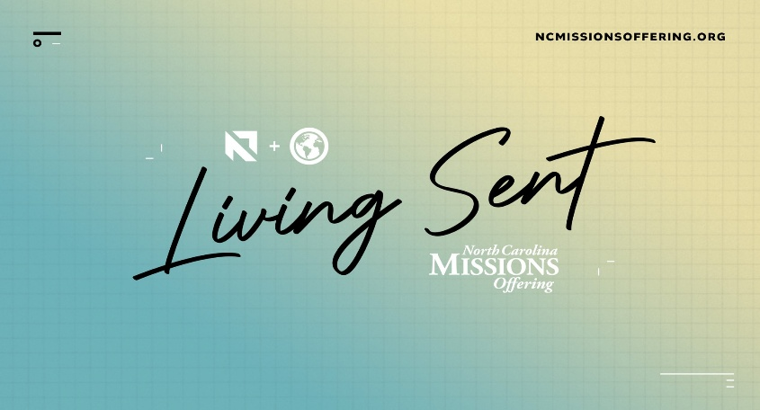
North Carolina Missions Offering (NCMO) is a special offering received during the month of September that brings relief to those in need, helps plant churches, and mobilizes N.C. Baptists for missions. We will collect for this offering throughout the month of September.

Save the date! Sunday, October 4th, will be our annual Havest Day Homecoming Celebration. Watch the bulletin for more information.
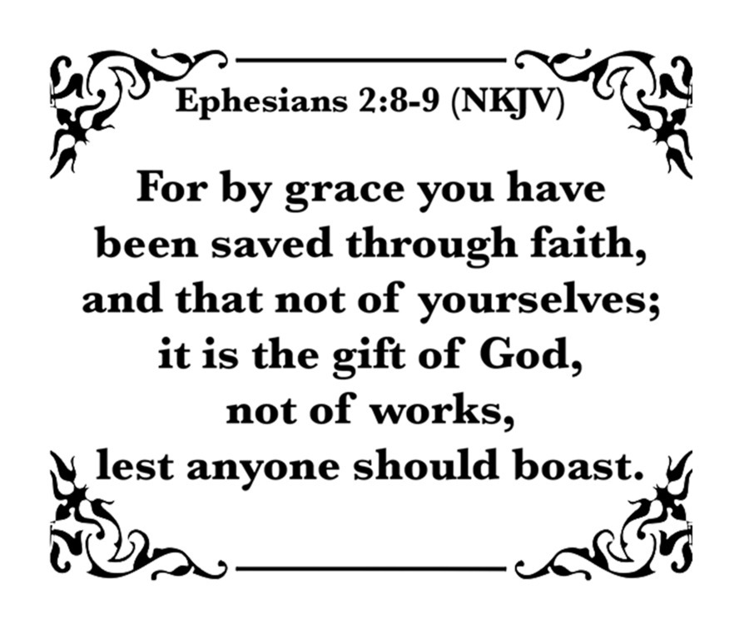
FIRST BAPTIST CHURCH CROSSNORE
PO Box 370
Crossnore, NC 28616
Church Office: 828-733-5243

Website: firstbaptistcrossnore.com

Office Hours: Monday-Friday 8:00am-3:00pm

Senior Pastor:
Pastor Jeremiah Parker (Cell: 828-291-8279)

Youth Pastor: Ean Martin

Administrative Assistant: Renee Gouge

Music Director: Tara Andrews

Pianist: Stephanie Watson

Chairman of Deacons:
Mr. Randall Aldridge (828-260-5820)

Prayer Chain Numbers:
Kathy Aldridge 828-733-9613 or 828-260-3199
Kay Grubb 828-733-6431 or 828-387-6994

Our Mission Statement at First Baptist Church, Crossnore is:
“To glorify God together in ministry by prayerfully living by His Word and sharing the Gospel of Jesus Christ through missions."

